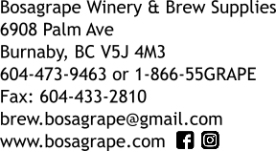

Bosagrape’s 2017 Fresh Juice Selection

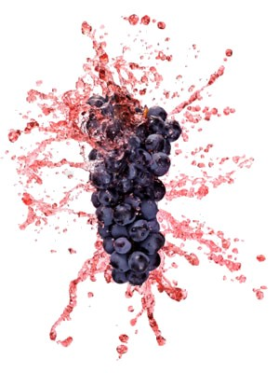

Important Information about Fresh Juices
- All fresh juices must be pre-ordered.
- The order deadline is October 18th
- The arrival date is November 8th
- A 50% deposit is required for any orders to be processed.
- We do not provide storage facilities for any fresh juices. You must be prepared to pick them up immediately once they arrive.
- Once we have confirmed the arrival date, we will notify you approximately 1 week in advance.

Fresh Juice with Crushed Grapes
Try the best of both worlds: the ease of juice, and the extra flavor and intensity of fermenting with real grapes. These larger-sized 30L pails contain 23L of fresh grape juice and a minimum of 4kg of crushed and de-stemmed grapes. You will not be disappointed.

Varietal | Origin | Price per pail
Cabernet Franc | Yakima Valley, WA | $135.75
Cabernet Sauvignon | California | $127.70
Cabernet Sauvignon | Yakima Valley, WA | $131.70
Merlot | California | $124.70
Pinot Noir | California | $124.70
Syrah | Yakima Valley, WA | $131.70
Zinfandel | California | $124.70

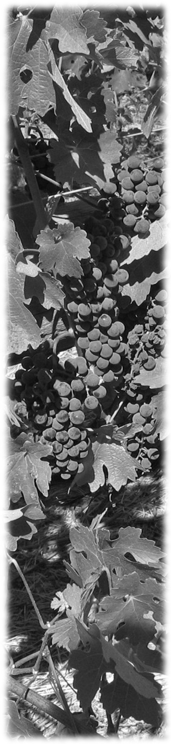

2017 “Fresco” Fresh Juices
Bosagrape is pleased to offer 35 varieties of fresh 100% grape juices. These juices are made from grapes sourced from Italy and the United States. They are packaged in 23L plastic pails and have been balanced for your convenience.
Varietal | Origin | Price per pail
Alicante | California | $81.00
Amarosso | Italian-style | $104.55
Barbera | California | $87.40
Blanc des Chateaux | California | $83.30
Bourgogne Royal | California | $85.40
Cabernet Sauvignon | California | $94.40
Castel del Papa | Italian-style | $101.70
Chenin Blanc | California | $83.30
Gewurtztraminer | California | $87.10
Granbarile | Italian-style | $104.55
Grenache Rose | California | $83.60
Il Toscano | Italian-style | $101.70
Il Veneto | Italian-style | $89.65
Italian Moscato* | Italy | $104.90
Lambrusco | Italy | $107.45
Merlot | Italy | $104.20
Montepulciano | Italy | $103.55
Moscato* | California | $83.30
Nebbiolo | Italy | $107.90
Nero D’Avola | California/ Italy | $107.90
Pinot Chardonnay | California | $102.35
Pinot Grigio | Italy | $101.35
Pinot Noir | California | $90.70
Primitivo | Italy | $104.90
Riesling | California | $89.65
Ruby Cabernet | California | $84.50
Sangiovese | Italy | $104.30
Sauvignon Blanc | California | $87.10
Shiraz | Californian-style | $101.70
Tocai | Italy | $98.55
Trebbiano | Italy | $98.55
Valle dei Tempi | Italy | $101.70
Vinho Verde | Californian-style | $96.70
Zinfandel, blush | California | $95.30
Zinfandel, red | California | $95.30
*Bosagrape offers two options for the Moscato varietal: Italian Moscato and Californian Moscato

AllGrape grape skin packs contain no sweeteners, concentrate, or added colour – simply 100% pasteurized crushed and de-stemmed grapes. Add to most red juices for increased body and bouquet.

AllGrape grape skin pack, 4kg $17.25
Nylon straining bag, 15x23
with drawstring $14.50

